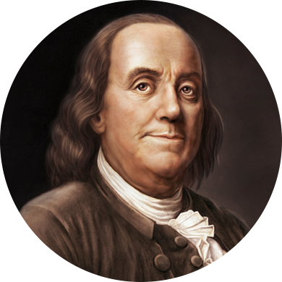
Benjamin Franklin the Diplomat
In government, he made contributions in developing unity and democracy in our colonies, and he also served for many years as official colonial agent in London for Pennsylvania. He pointed out for a long time to the British Government that taxation without representation was a principle upon which America stood firmly.
When Franklin went to France in the early part of the Revolution as the official diplomat and ambassador of the thirteen colonies, he came as a man of maturity, brilliance, ability, and as a world statesman. Upon his arrival in Paris, there was no other statesman or philosopher who could equal him in his ability and accomplishments. His presence in Paris annoyed the British minister and staff. Franklin enjoyed the situation. The years he remained in Paris were unusually fruitful ones for America and helping to work out the future destiny of the United States of America.
The colonies indeed needed help of every description--men, money, equipment, ships, and all things to fight a successful war. The long years of enmity between France and Britain opened the way for the leadership of Franklin. And he was not only the man to exploit it, but also the reason for the acceptance of thirteen states as a recognized nation in the world of nations.
Once the war was over and there were those in power who thought they could use Franklin, the American alliance and the United States to their own advantage. The French politicians were opposed to a separate peace treaty for the United States, but they proposed to have a treaty in which American independence and sovereignty would be tied directly to the French treaty. And then they could hold the United States under their own direction.
Franklin knew French politicians too well, and he resolved such conditions should not result. Franklin was courageous, bold and had a definite sense of vision plans in diplomacy. Consequently, he met the leaders of the British commission and secured a separate treaty with them. He secured just what he wanted for his country; namely, the absolute independence of the United States, recognition of it as a distinctive government, and at the same time the exact boundaries of the United States were generally established.
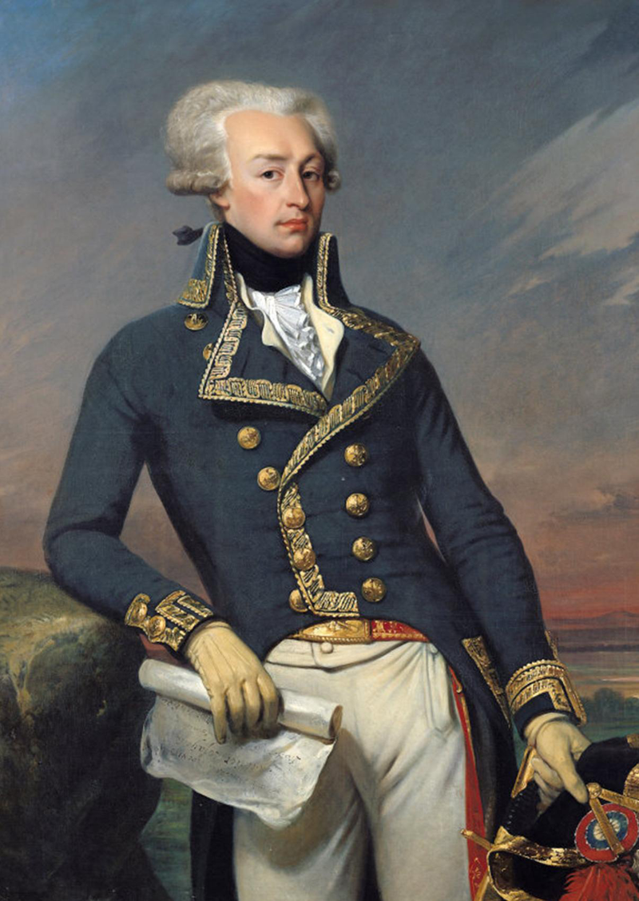
Marquis de Lafayette
King Louis XVI (1754–1793) refused to allow Lafayette to go to America, but Lafayette sailed anyway, after buying a ship with his own money. In June 1777 he landed in North Carolina. The Continental Congress had given him a commission as a major general, but his actual duties were as assistant to General George Washington (1732–1799). He assisted in battles against the British in Pennsylvania and New Jersey and eventually was sent back to France in an attempt to obtain greater French support for the Americans.
Upon returning to his homeland in 1779, Lafayette was arrested for having disobeyed the king, but all was soon forgiven. Although not all his proposals for aid to the Americans were approved, Lafayette returned to America in 1780 in command of French forces that were sent to help. In 1781 he was given command of the defense of Virginia with the rank of major general. He drew English commander Charles Cornwallis (1738–1805) into a trap at Yorktown, Virginia; Cornwallis was blockaded by the American forces and by French troops under Admiral de Grasse. Cornwallis's surrender was the high point of Lafayette's military career.
When Lafayette returned to the French army in 1782, he was considered a hero. He became a leader in the movement against the French monarchy (absolute rule by a single person). In 1789 he took a seat in the Estates General, the French legislature. The adoption of the Declaration of the Rights of Man and the Citizen (loosely based on the Declaration of Independence) was his idea, and he was given the command of the Parisian National Guard, a force of citizen-soldiers created to defend the new constitutional monarchy.

